**Dxc _assignment _day-4**

**Shaik Mohammed Raihan**

**Case study-4**

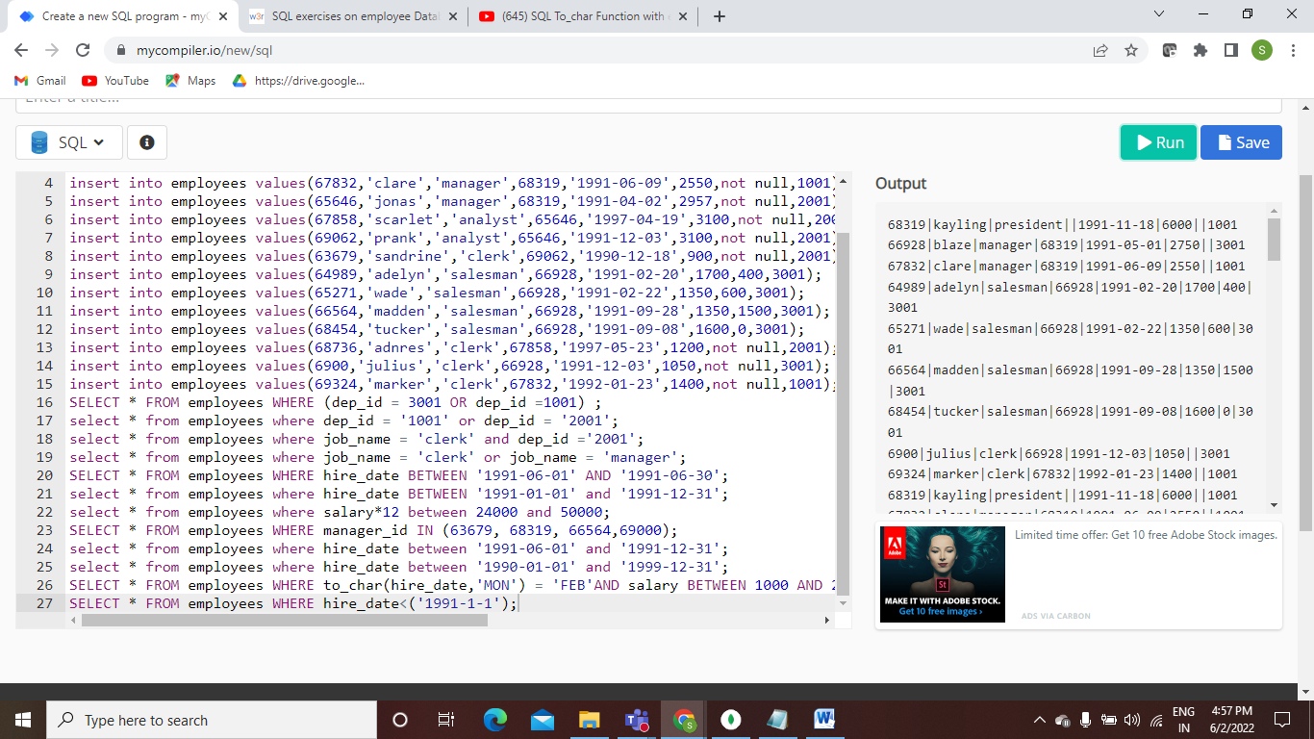

**Quires:-**

SELECT * FROM employees WHERE (dep_id = 3001 OR dep_id =1001) ;

select * from employees where dep_id = '1001' or dep_id = '2001';

select * from employees where job_name = 'clerk' and dep_id ='2001';

select * from employees where job_name = 'clerk' or job_name = 'manager';

SELECT * FROM employees WHERE hire_date BETWEEN '1991-06-01' AND '1991-06-30';

select * from employees where hire_date BETWEEN '1991-01-01' and '1991-12-31';

select * from employees where salary*12 between 24000 and 50000;

SELECT * FROM employees WHERE manager_id IN (63679, 68319, 66564,69000);

select * from employees where hire_date between '1991-06-01' and '1991-12-31';

select * from employees where hire_date between '1990-01-01' and '1999-12-31';

SELECT * FROM employees WHERE to_char(hire_date,'MON') = 'FEB'AND salary BETWEEN 1000 AND 2000;

SELECT * FROM employees WHERE hire_date<('1991-1-1');